**FULL STACK DEVELOPER COURSE**

**(By MyGreatLearning)**

1. Agenda
2. Web Development Architecture
3. Type of Web Developers
4. Who is a Full Stack Developer
5. Layers of Full Stack Development
6. Business Layer
7. Database Layer
8. Some Extra Important Technologies
9. Salaries Offered to Developers in India
10. Common Myths
11. What is the Correct Path
12. **Agenda**

The Above listed Topics will be covered under this Course.

1. **Web Development Architecture**

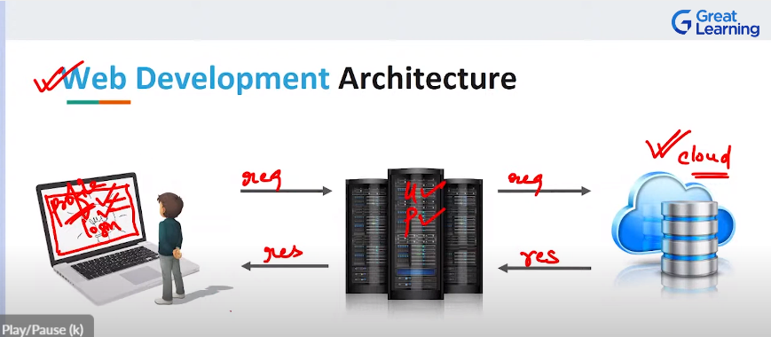

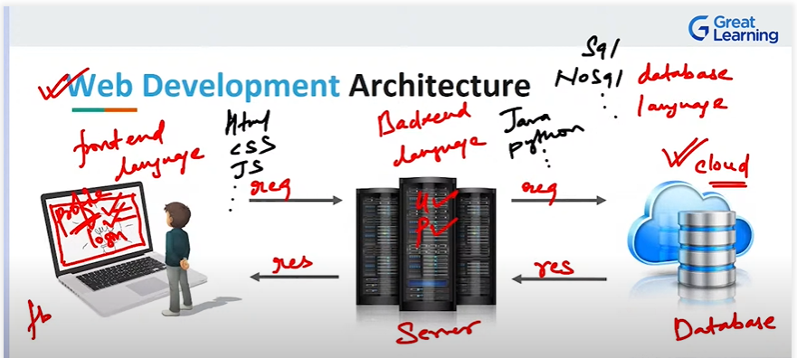

1. **Type of Web Developers**

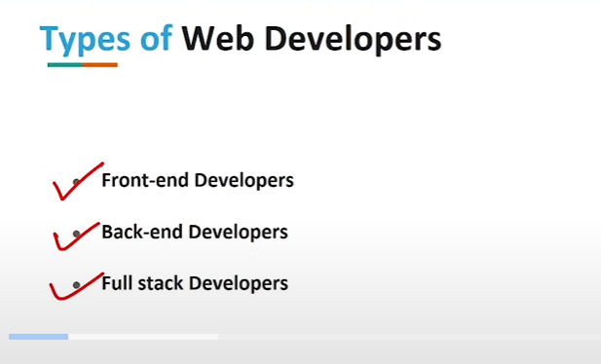

1. **Who is a Full Stack Developer**

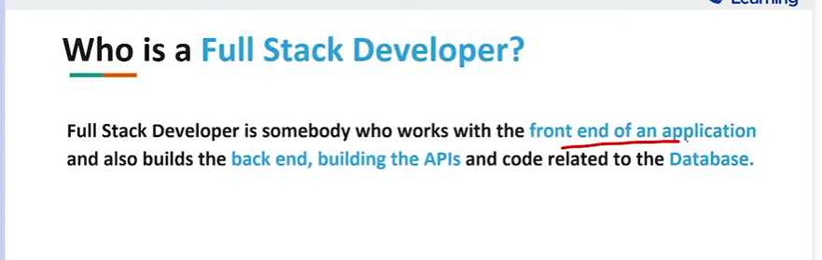

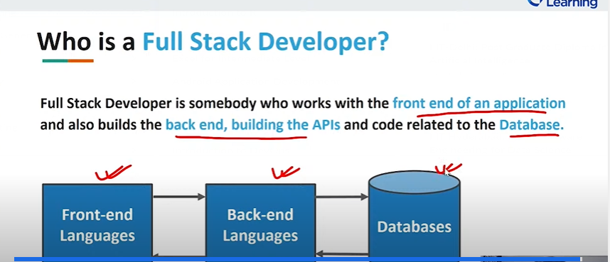

1. **Layers of Full Stack Development**

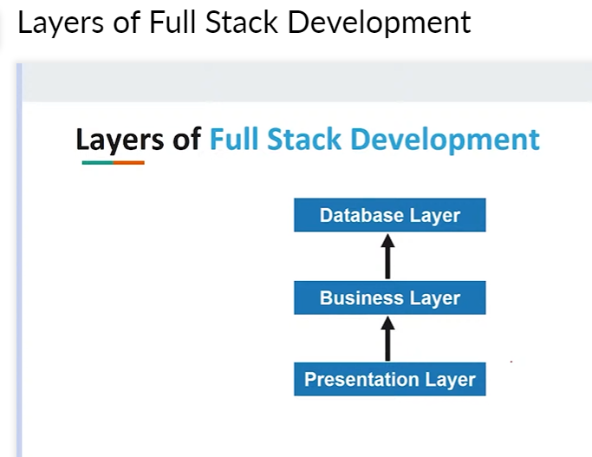

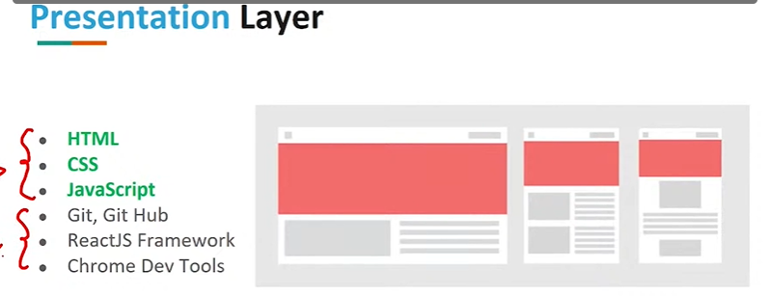

1. **Business Layer**

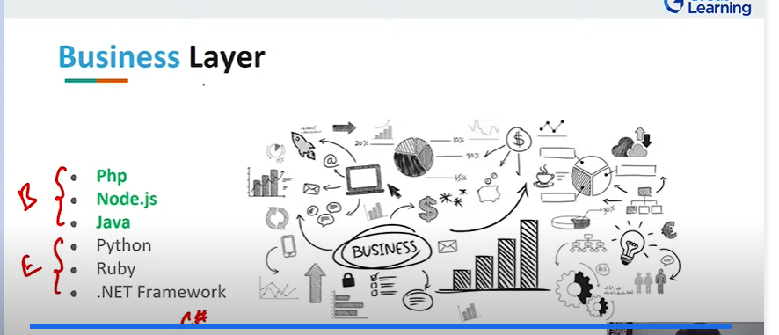

1. **Database Layer**

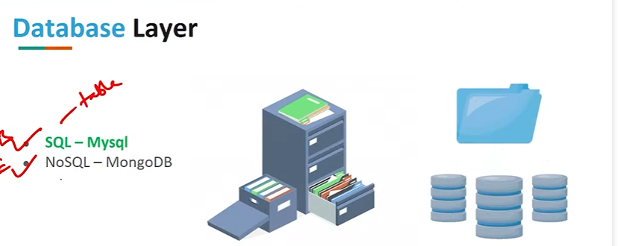

1. **Some Extra Important Technologies**

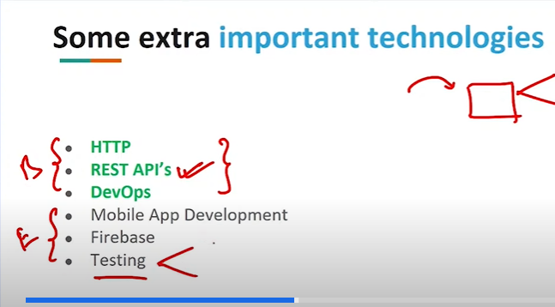

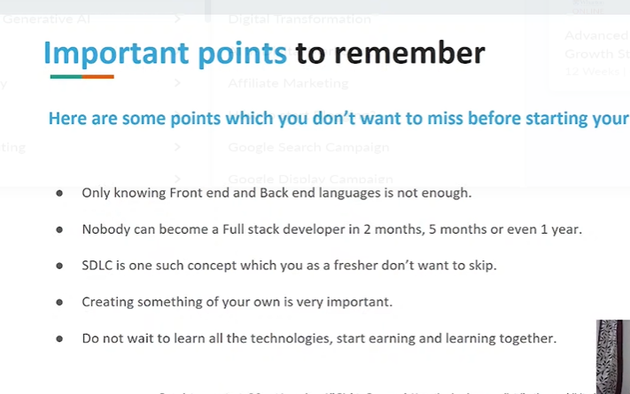

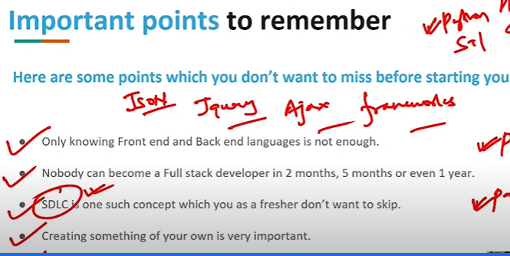

1. **Salaries Offered to Developers in India**

Based on every Financial Year

1. **Common Myths**

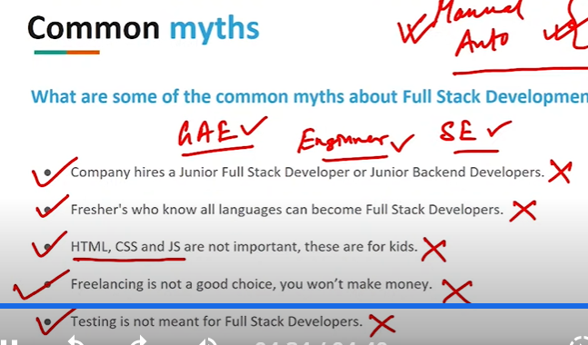

1. **What is the Correct Path**

